Proposal for Advanced 3-Dimensional Modeling Environment

Title: 16pt Arial

All comments in red and blue boxes should be deleted.

**This template (Extended Abstract) can be used if you want to make your presentation into a paper and submit it to the 4DFF e-journal after your presentation.**

The file name at the time of submission should be as follows．If you wish to resubmit a revised manuscript, please increase the update number (01 for the first time).

Receipt number _Authors Name_update Number.pdf Example: 05_Masahiko FUJII_01.pdf

Authors Name: 12pt Arial

Taro FUJI, Hanako KEIOU

Affiliation: 10pt Arial

Rippoutai Modeling Co., Ltd., University of Yokohama-Minto

Chapter Heading：10pt Arial

Text：10pt Times New Roman

Deployment of affiliation, pre-names of faculties, etc., may be omitted.

【**Extended Abstract**】

1. Introduction

This research proposes a new modeling method for 3D objects. This method enhances a linkage between simulations and modeling, and it leads to enrich fabrication abilities of 3D printers directly. In this method, each voxel can store various information such as color, material, link which describes relationship to neighbor voxel) and attributes defined by users. And it will support to simplify flows of 3D data and work together with simulations. Thus, it will contribute to improving the value of applications using 3D printers.

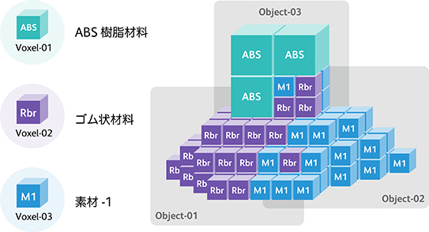

Please include about one representative figure.

Fig.1. Example of 3D model description by FAV

Figure Caption: 9pt Arial

Instead of describing only the surface of a 3D model with a mesh (polygon) as in conventional 3D data formats, the 3D model is represented with voxels, which are the basic elements of 3D, such as cubes and spheres. Various attributes can be defined for each voxel, including color information such as RGB and CMYK, and material information such as ABS resin and nylon. FAV enables the creation of highly expressive three-dimensional objects, including the detailed design of the distribution of multiple materials, such as hard and soft materials, and the free design of intricate internal structures.

2. Conclusion

Since voxels can be used to define 3D shapes, it is possible to represent various structures such as microstructures, endohedral structures, and repetitive structures by combining different types of voxels, or by combining with and without voxels. The following advantages can be obtained by defining a three-dimensional object with a stack of basic elements called voxels.

Reference

A. Masumori, H. Tanaka, “Voxel-based 3D Processing for 3D Printing”, NIP31 (2015), pp.285.

**If it does not fit on one page, it may be spread over two pages.**

No Page Number

Please delete this comment box and all comments in red or blue boxes, such as font size instructions, when submitting the document.

Please submit your proceeding in pdf format.

The submitted pdf file will be used as the manuscript as it is.

If you cannot convert to pdf, please contact the following address.

Contact：m.fujii@inkcube.org