Proposal for Advanced 3-Dimensional Modeling Environment
Title: 16pt Arial
The file name at the time of submission should be as follows．If you wish to resubmit a revised manuscript, please increase the update number (01 for the first time).
Receipt number _Authors Name_update Number.pdf
Example: 05_Masahiko FUJII_01.pdf
All comments in red and blue should be deleted.

Taro FUJI ¹，Hana KEIO²
Authors Name: 12pt Arial

¹Rippoutai Modeling Co., Ltd., ²University of Future Technology
Affiliation: 10pt Arial

Abstract: 10pt Times New Roman (around 100 words)
【Abstract】
This research proposes a new modeling method for 3D objects. This method enhances a linkage between simulations and modeling, and it leads to enrich fabrication abilities of 3D printers directly. In this method, each voxel can store various information such as color, material, link which describes relationship to neighbor voxel) and attributes defined by users. And it will support to simplify flows of 3D data and work together with simulations. Thus, it will contribute to improving the value of applications using 3D printers.
Keywords:3D, simulation, modeling, voxel, attribute
Keywords: 9pt Arial
Chapter Heading：10pt Arial
Text：10pt Times New Roman

1. Introduction
Instead of describing only the surface of a 3D model with a mesh (polygon) as in conventional 3D data formats, the 3D model is represented with voxels, which are the basic elements of 3D, such as cubes and spheres. Various attributes can be defined for each voxel, including color information such as RGB and CMYK, and material information such as ABS resin and nylon. FAV enables the creation of highly expressive three-dimensional objects, including the detailed design of the distribution of multiple materials, such as hard and soft materials, and the free design of intricate internal structures.

2. Concept
FAV stands for FAbricatable Voxel. 3D model data described in FAV format is fabricatable, meaning that it is stored as optimized information for use in manufacturing. Optimized information that can be used for manufacturing indicates the following.

3. Conclusion
Since voxels can be used to define 3D shapes, it is possible to represent various structures such as microstructures, endohedral structures, and repetitive structures by combining different types of voxels, or by combining with and without voxels. The following advantages can be obtained by defining a three-dimensional object with a stack of basic elements called voxels.
No Page Number
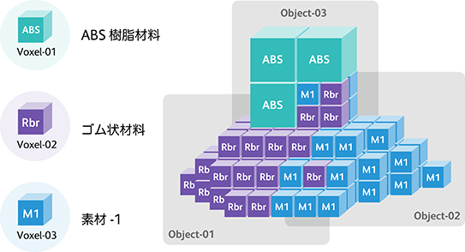
Fig.1. Example of 3D model description by FAV
Figure Caption: 9pt Arial

Reference
1. A. Masumori, H. Tanaka, “Voxel-based 3D Processing for 3D Printing”, NIP31 (2015), pp.285.
2.
Proceeding should be no more than 4 pages in length; if your manuscript exceeds 4 pages, please contact the following address.
If the number of pages is odd (1 or 3), please understand that a blank sheet of paper will be inserted on the last page.
Please delete this comment box and all comments in red or blue, such as font size instructions, when submitting the document.
Please submit your manuscript in pdf format.
The submitted pdf file will be used as the manuscript as it is.
If you cannot convert to pdf, please contact the following address.
Contact：m.fujii@inkcube.org

